## ACIT 1620 – Midterm Review

## Practice Quiz

(1) Navigating on the web can be summarized as a series of interactions between two types of systems: clients and servers.

True

False

------------------------------------------------------------------------------------------------------------------

(2) Given the URL [https://learn.bcit.ca](https://learn.bcit.ca/), bcit.ca is the _____.

Protocol

Domain

Hostname

Pathname

------------------------------------------------------------------------------------------------------------------

(3) Which is the correct document type declaration?

<!DOCTYPE html>

<DOCTYPE= “html” />

<document type = “html” />

<document> <html> </ html> </document

------------------------------------------------------------------------------------------------------------------

(4) What is true about the <html> tag?

It has two child elements <head></head> and <body></body>

It has only one child element, <head></head>

It has two child elements, <header></header> and <body></body>

It has only one child element, <body></body>

------------------------------------------------------------------------------------------------------------------

(5) Websites have either an IP address or a domain name, but not both.

True

False

------------------------------------------------------------------------------------------------------------------

Which attribute will <img> tags display if the image cannot be loaded?

Title

Alt

Src

Href

------------------------------------------------------------------------------------------------------------------

(6) <img> tags can be nested inside <a> tags

True

False

------------------------------------------------------------------------------------------------------------------

(7) Which of the following elements start a new line? (Select all that apply)

<em></em>

<section>

<img />

<h3></h3>

<p></p>

<article>

<strong></strong>

------------------------------------------------------------------------------------------------------------------

(8) Given the code snipped below:

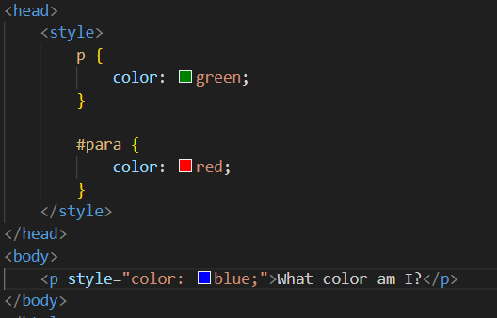

What color will be applied to the paragraph?

Red

Green

Browser default

Blue

Explanation:

1. **p { color: green; }** - This rule applies to all <p> elements and sets the color to **green**.
2. **#para { color: red; }** - This rule applies to the <p> element with the specific id="para" and sets its color to **red**.
3. **style="color: blue;"** - This is an **inline style** applied directly to the <p> element, setting the color to **blue**.

In CSS, inline styles have the highest specificity, meaning they override both element and ID selectors. So, the paragraph will be colored **blue** due to the inline style.

------------------------------------------------------------------------------------------------------------------

(9) CSS inline styles are specified using the **style** element

True

False

------------------------------------------------------------------------------------------------------------------

(10)Consider the code snippet below:

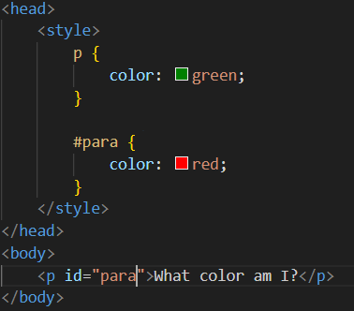

Which color will be applied to the paragraph whose id attribute is "para"?

Browser default

Red

Green

Explanation:

There are two rules that apply to the <p> element with the id="para":

1. **p { color: green; }** - This rule targets all <p> elements and sets their color to **green**.
2. **#para { color: red; }** - This rule targets the <p> element with the specific id="para" and sets its color to **red**.

Because **ID selectors** (#para) have higher specificity than **element selectors** (p), the color set by the #para rule (which is **red**) will take precedence. So, the paragraph with id="para" will have its text color set to **red**.

------------------------------------------------------------------------------------------------------------------

(11) Given the code snippet below:

What is the background color of the <div> element whose class is "container"?

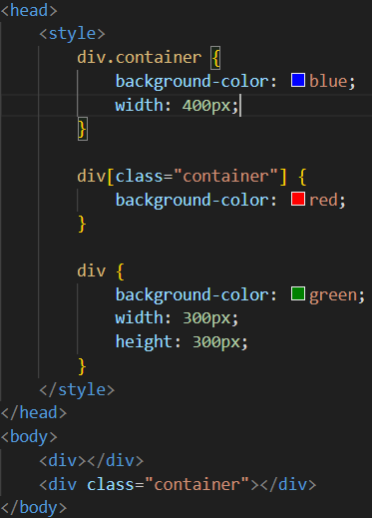

Red

Green

Blue

Explanation:

1. **div.container** - This rule targets a <div> element with the class container. It sets the background color to **blue**.
2. **div[class="container"]** - This rule targets a <div> with the class="container" attribute. It sets the background color to **red**.
3. **div** - This rule targets all <div> elements and sets the background color to **green**.

Now, the specificity of each selector:

* div.container: This has a specificity of 0-1-1 (one class selector and one element selector).
* div[class="container"]: This has a specificity of 0-1-1 (same as the previous rule).
* div: This has a specificity of 0-0-1 (just an element selector, which is lower).

Since both the first and second rules have the same specificity, **the order of the rules** matters. The last rule in the CSS that has the same specificity wins in case of a tie.

Thus, the background color of the <div class="container"> will be **red**, because the div[class="container"] rule comes after div.container in the stylesheet.

------------------------------------------------------------------------------------------------------------------

(12) Consider the following folder structure for a simple website:

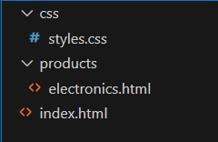

What would be the correct way of including the styles in styles.css into the electronics.html page?

<link rel="stylesheet" src="../css/styles.css" />

<link rel="stylesheet" href="css/styles.css" />

<link rel="stylesheet" href="../../css/styles.css" />

<link rel="stylesheet" href="../css/styles.css" />

-----------------------------------------------------------------------------------------------------------------

(13) Consider the following code snippet:

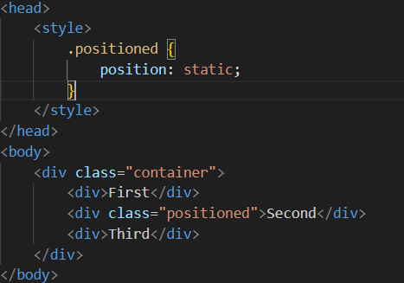

Where will the <div> element with class "positioned" appear?

At the top of the page

Between the first and third <div> elements

Overlapping with the first <div> element

At the top of the containing element

(14) Websites are often described has having three 'layers': HTML, CSS and JavaScript. What is the HTML layer responsible for?

Presentation

Content

Behaviour

Database

------------------------------------------------------------------------------------------------------------------

(15) Comments in HTML and CSS can be used to document code, as well as hide or disable elements and styles. Which of the following are the correct comment tags for HTML?

//  
#

**/* */**

**<!-- -->**

------------------------------------------------------------------------------------------------------------------

(16) The value of an id attribute on an HTML element should be unique, i.e. only appear once per page

True

False

------------------------------------------------------------------------------------------------------------------

(17) Which of the following is a required attribute for the img element?

Rel

Href

Class

Src

------------------------------------------------------------------------------------------------------------------

(18) Which of the following attributes is required on an img element to ensure that the image is accessible (e.g. can be read by screen readers)

Src

Id

Text

Alt

------------------------------------------------------------------------------------------------------------------

(19) Which of the following is a required attribute for links, i.e. <a> elements?

Src

Href

Target

Alt

------------------------------------------------------------------------------------------------------------------

(20) Which of the following is not one of the semantic HTML5 tag names discussed in class?

Main

Section

Header

Navigation

------------------------------------------------------------------------------------------------------------------

(21) Given a set of elements that need some common styling, the correct attribute (and associated selector in CSS) to add to those elements in HTML is a(n):

Class

Src

Id

Style

------------------------------------------------------------------------------------------------------------------

(22) Which of the following is an inline element?

<strong></strong>

<h1></h1>

<div></div>

<p></p>

------------------------------------------------------------------------------------------------------------------

(23) Given the following URL, which portion is the filename?

mozilla.org/en-US/docs/Web/HTML/index.html

index.html

developer.mozilla.org/en-US/docs/Web/HTML/index.html

/en-US/docs/Web/HTML/index.html

------------------------------------------------------------------------------------------------------------------

(24) The only element that should appear as the direct child of a <ul> or <ol> element (i.e. nested one level inside) is an <li>

True

False

------------------------------------------------------------------------------------------------------------------

(25) Which of the following will correctly load a stylesheet named style.css into an HTML page?

<style href="style.css"></style>

<link rel="style.css" href="stylesheet">

<style src="style.css"></style>

<link href="style.css" rel="stylesheet">

------------------------------------------------------------------------------------------------------------------

(26) Which of the following is *not* part of what makes up a CSS rule?

Selector

Value

Property

Attribute

------------------------------------------------------------------------------------------------------------------

(27) Which of the following is the correct order of selectors in decreasing weight (lowest weighted selector last, highest weight selector first)?

id, class, element

element, class, id

class, id, element

class, element, id

Explanation:

**ID selectors** (#id) are the most specific because they target a unique element within the page. IDs are meant to be unique across the entire document, so they have the highest specificity.

**Class selectors** (.class) are less specific than IDs. Classes can apply to multiple elements on a page, but they are more specific than elements because they are more targeted.

**Element selectors** (e.g., div, p, h1) have the lowest specificity. They apply broadly to all elements of a certain type, which makes them the least specific.

In decreasing order of specificity, it goes: **id (highest)** → **class** → **element (lowest)**.

------------------------------------------------------------------------------------------------------------------

(28) Which of the following rules would correctly select all divs and spans on the page and change their background color to blue?

div, span {  
    background-color: blue;  
}

divs, spans {  
    background-color: 'blue';  
}

div span {  
    background-color: blue;  
}

div + span {  
    background-color: 'blue';  
}

------------------------------------------------------------------------------------------------------------------

(29) Which of the following properties is not part of the CSS box model?

Padding

Margin

Border

all of the above are part of the CSS box model

------------------------------------------------------------------------------------------------------------------

(30) Which CSS animation property is used to configure how many times an animation should repeat?

animation-count

animation-repeat

animation-duration

animation-iteration-count

------------------------------------------------------------------------------------------------------------------

(31) What is the 'at-rule' used to define the appearance/behaviour of a CSS animation?

@appearance

@animation

@keyframes

@media

------------------------------------------------------------------------------------------------------------------

(32) Which of the following is a valid custom property (i.e. CSS variable) declaration?

var(--color-primary): red;

var(colour-primary): red;

color-primary: red;

--color-primary: red;